4th ANNUAL “Be the change” banquet

Help Us Stop Addiction

Thursday, September 17th , 2026 6 pm – 8 pm
Donald W. Reynolds Center
105 Reynolds Ave., Poteau, OK 74953
Dinner Catered by Eli French
~ Silent Auction ~
Testimonies ~ Addiction Awareness

Banquet Tickets $40 each / Whole Table (8 tickets) $300
Sponsorship Only (no tickets) $250 or More
Sponsorship & 8 Banquet Tickets $550
(Advertising Included with Sponsorship)
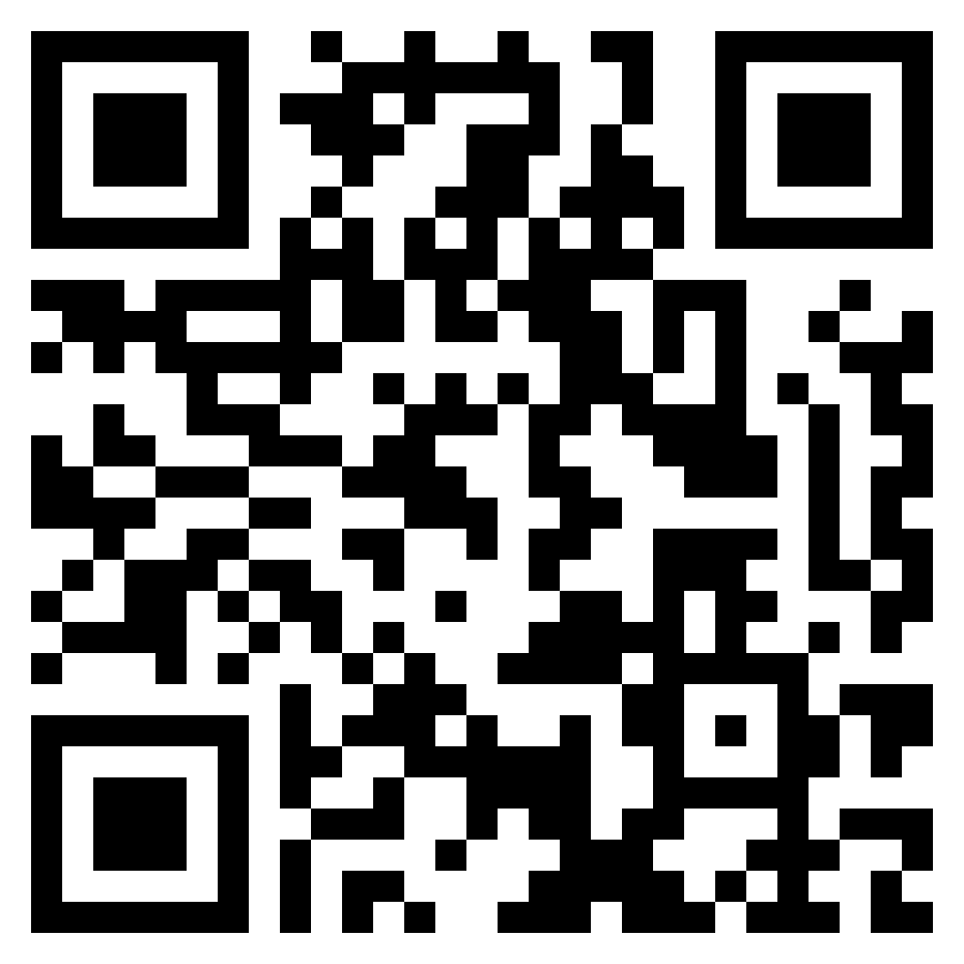
Tickets available at Second Chances Store
1100 S Broadway Ave., Poteau, OK,
online www.secondchancesok.com or
scan this QR Code
Someone is counting on YOU to “Be the Change” in our community!
Thank you for supporting recovery and helping make a hopeless situation POSSIBLE!

